Project Proposal
EECS 581
Team 4

October 23rd, 2017

Table of Contents
Table of Contents
Team Information
Project Description
Project Milestones
Project Budget
Work Plan
Github Link
Preliminary Project Design
Scripting
Physics
Environment Physics
Player Movement
Object Interaction
Overall Progression of the Game
Necessary Objects for Quality Gameplay
Accurate Hit Boxes
Good User Interaction Design
Assets
Graphics
Themes
Player Model
Ethics and Intellectual Property Issues
Change Log

Team Information
Team Name: Team 4
Team Members and email addresses:
- Brock Sauvage: b080s094@ku.edu
- Denae Douglas: d102d638@ku.edu
- Keshawn Triplett: k908t147@ku.edu
- Luciano Fasani Ortiz: l186f489@ku.edu
- Matthew Bauer: m884b405@ku.edu
Team Meeting time: October 23rd, 4:00 PM (Mondays)
Lab Meeting time: Wednesdays, 4:00 PM
Contact: Brock Sauvage
Project Sponsor (if any): None

Project Description
This project is going to be an “escape room” game experience where you solve puzzles and mind games in virtual reality, and is being undertaken in order to address emerging opportunities for virtual reality experiences in the gaming and technology consumer markets. As virtual reality becomes more commonplace in the homes of consumers, the demand for unique and effective virtual reality experiences increases. We believe that this project would fulfill this demand. This project will feature graphics, music, mechanics, and a story that is developed originally by the team, and will utilize the features of the Vive virtual reality system in order to allow users to investigate and interact with the virtual space by moving around in a physical space. The end result of this project will be a cohesive experience in which users will experience a story that has been enhanced by effective usage of virtual reality mechanics, music, and graphics.

Project Milestones
First Semester:
- Acquire all necessary hardware and software materials - 10/31/17
- Setup development environment and demonstrate functional demo - 11/15/17
- Project Proposal Report (including UML, Gantt charts, etc.) - 10/23/17
- Workable project prototype to demonstrate concept - 12/15/17
Second Semester:
- Story, graphical/modeling materials, music finished - 1/31/18
- Project mostly finished and ready for testing: testing commences. - 3/31/18
- User testing and validation - Done throughout development, done 4/15/18
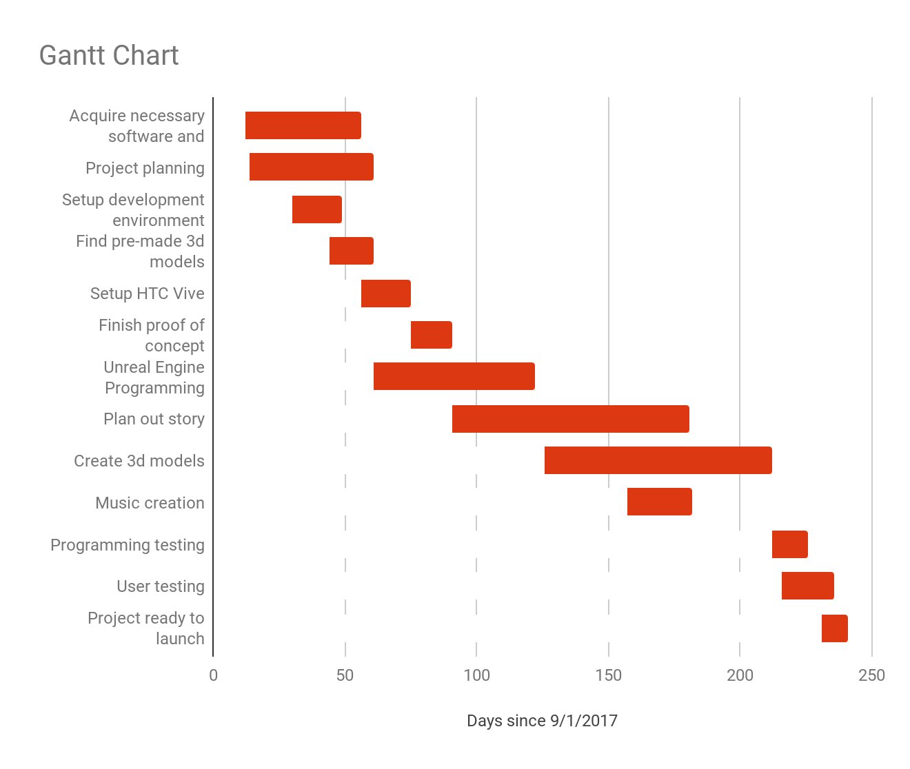
- Project ready to launch - 5/1/18

Project Budget
- Vive: $600 https://www.vive.com/us/
- Vive Audio Strap: $100
- Stands: $35.99 https://www.amazon.com/Neewer%C2%AE-Studio-Portrait-Product-Photography/dp/B00L4YR0BS/ref=pd_bxgy_421_img_2?ie=UTF8&refRID=08WDQ8G6BKT9YFY19H1E
- Ball Head Mount x2: $6.99 each
https://www.amazon.com/gp/product/B012FTXOW4

Work Plan
Each member of the team will be responsible for creating a section of the escape space. Each team member will function as a “full stack” developer of sorts.

Github Link
https://github.com/lucianofasani/KuCapstoneTeam4

Preliminary Project Design
The main parts of this project are: Scripting, User Interaction, Level Design, and Assets(models and audio), and storyline. We will use different development environments for the majority of these parts, but it will all come together in the Unreal Engine.

Scripting

The majority of the work we do will be scripting. We chose Unreal Engine because we needed an engine to work off of, since writing our own engine would put this project very out of scope for us. Unreal Engine’s scripting is written in C++. The scripting will allow us to modify physics, object interaction, player movement, game sequence and logic.

Physics

The scripting we do when it comes to physics will be mainly about how certain objects behave in the space they are in. We may have special cases when the environment may dictate how objects existing in them work. Power (or lack of) of gravity, the bouncing of objects, etc.

Environment Physics

As stated above, the only physics we will be scripting are the special cases when things in the game trigger certain modifications to the physics of the environment.

Player Movement

We won’t have to worry about too much when it comes to physics of the player movement. We will be using teleportation for the majority of the player movement, and when it comes to walking around we don’t have to worry about physics since it will match real life. We will need to script for the bounding of the teleportation in order to avoid having to worry about the player leaving the play space.

Object Interaction

There will need to be a script for every different type of object. For example if we have a dresser and drawers for the dresser, we need to only allow the drawers to move and limit them to a certain space. For certain objects we’ll need to write scripts about what happens when the player interacts with it in some manner, whether it be the player touching the object, picking it up, or simply walking towards it. The end result of these interactions will be the triggering of events.

Overall Progression of the Game

Puzzles
Since we are doing an escape room styled game, the main gameplay feature and challenge is the solving of puzzles in order to progress through the game. We’ll need to come up with the ideas of what we want the main puzzles in each section of the game to be, and script those into the levels. How we will go about doing this is by splitting the level into multiple “states” until you eventually reach the final state.

Pressure
We also plan on scripting a feature that acts as a countdown in that it will put pressure on the player, and eventually if they don’t solve what they need to in time, they fail.

Save States
Since this is a single player, story based game, there will need to be a way to be able to start off where you left off, or at least start somewhere near. Therefore we will need to be able to have a save state system or checkpoint system.

Necessary Objects for Quality Gameplay

Accurate Hit Boxes

In VR almost everything needs to be interactive in order to have a more immersive experience. This amplifies the need to have accurate hit boxes, so we will be using mesh colliders to best handle the collision between objects. We will use this to avoid clipping, and other unfavorable glitches. We also need to test what happens when multiple objects collide at once, because that is when glitches occur. We’ll also write scripts for certain collisions, like when a player touches a certain object. Everything needs to have hit boxes.

Good User Interaction Design

This will be a big one because the gameplay needs to be smooth and intuitive. We will need to develop our own in-game menu system, we don’t have a lot of button on the Vive controller to use, but we do have motion controllers and an accurate touchpad. So we need to develop an interface that uses our tools to the best of our ability. Another big user interaction design aspect that needs to be done well is the inventory system. In order to not stop the flow of gameplay, the inventory needs to be easily accessible and usable at all times.

Assets

Graphics
The majority of the models to be used the in the game will be developed using an open-source modelling tool known as Blender. Blender will allow us to create specialized objects that will live and function in the virtual environment. The models designed in blender will be incorporated with varying amounts of detail, dependent upon the amount of interaction the player will have with the object.

Themes
Our game will feature several different rooms that will follow a central storyline and theme. Each of the rooms will have models of unique design and style, while incorporating features from the overarching story line. Each distinct room will include objects of similar style and design.

Player Model
In the game, the controllers used by the players will be modeled after a set of hands constructed in Blender. The hands will be animated to do simple task such as grabbing and opening, and will act as the user’s interaction with the other objects. Since the hands are the focal of the user’s interaction with other objects, they will have a higher priority for detail.

Object Models
Objects that will be used in each of the rooms will be created with the use of blender. The design of different objects will be dependent on the theme of the room it is being designed for. Objects with separate movable parts, such as a dresser with multiple drawers, will be created piece by piece in blender. The Unreal engine will then be used to mold the pieces into an interactive object. Objects that will have direct interaction with the user will have a higher priority for detail than static objects.

Sound/Audio

Background Music
For background music, we will use multiple different soundtracks depending on the theme of the room. For the main menu, we will use a script that will allow various songs to play in the background in a loop. For the in-game background music, each room will have a distinct track that will be played for the majority of scene.

Item Interaction Noises
In order to make the game more realistic, scripts will be written so that he he when certain interactions happen different sounds will be played. For example, the pulling of a lever will trigger a script that will play a sound of screeching metal. For the menu, we will add scripts that will play sounds when different options are selected.
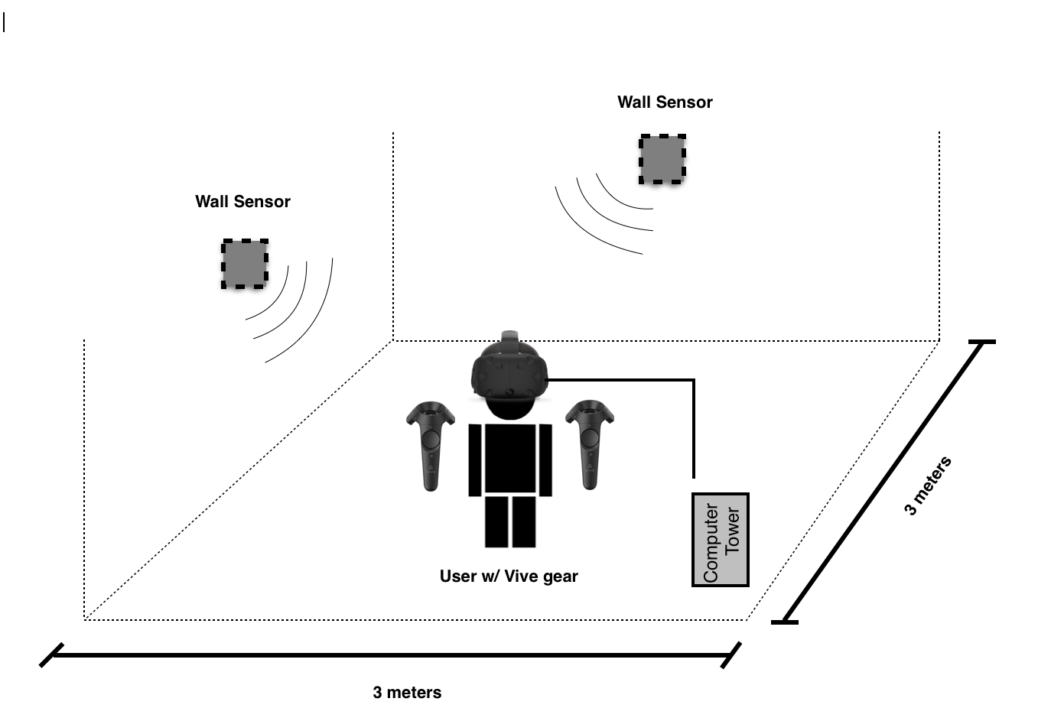
Figure 1: An environmental use-case diagram. Photo sensors connected to the walls determine the position of the headset and controllers. The headset is connected via cord to a computer tower running the software. The approximate space for play is 3m x 3m, well above the recommended play space.

Project Concept & Objectives  We designed a virtual reality gaming experience in which the user finds themselves “trapped” in a room. They must use a series of clues and the underlying plot of the storyline to escape various rooms throughout game. The user will be tested mentally and physically with various pressures techniques in the game, providing an adequate amount of urgency to escape rooms before time runs out. | Technologies Used  - VR System: We utilized the HTC Vive with headset, controllers, and tracking stations as our virtual reality system.  - Gaming Engine: The Unreal Engine served as the development platform for the gaming experience. Scripting for the game was written in C++.  - Sound: Sibelius was used to create the sound effects and background music to our game.  - Graphics: Developed using Blender, a 3D modeling software, and other open source designs.
Test & Evaluation  - The game should give the user the immersive gaming experience expected from VR technology.  - The user should have the ability to easily use any interactive objects.  - The end product should be fully playable, meaning give the user unlocks all puzzles provided in the storyline, they are able to successfully escape the room and resolve the game. | Virtual Reality  Our game will use the latest in VR technology to provide a product that has not yet saturated the market.  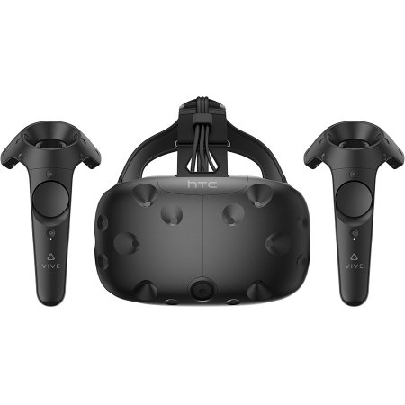

Figure 2: A table describing project concept, specific technologies used, and how testing is conducted.

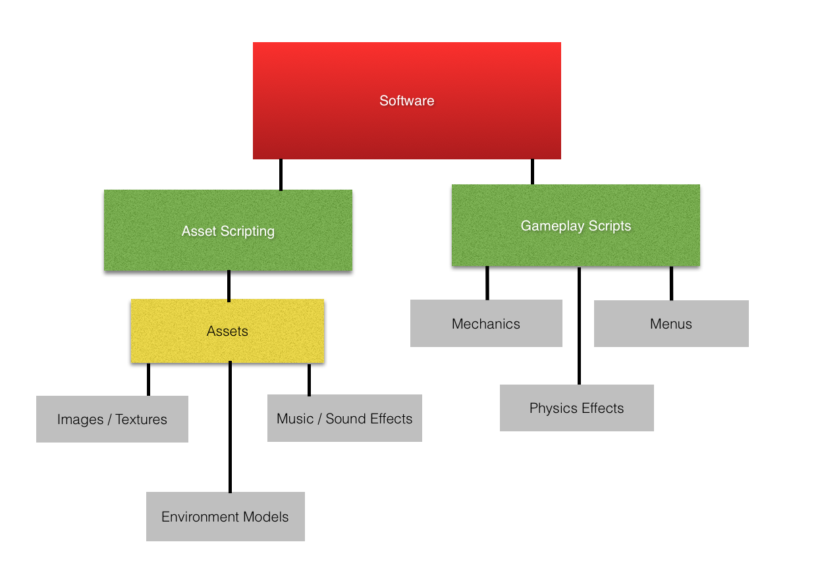

Figure 3: A diagram visualizing how the assets and scripts will be organized and culminate into the overall software.

Ethics and Intellectual Property Issues
In regards to ethics, issues arise primarily in the realms of both “content” and “context.” That is to say, both the game that users will be experiencing and the medium (virtual reality) that they will be experiencing it through both elicit concerns that must be addressed. First, we’ll start by looking at the content of the experience itself.

Because the story of our game may be somewhat “dark” in nature and contain elements that aren’t suitable for some younger audiences, an ethical dilemma arises if certain individuals attempt to experience our game. This falls into a “Respect for Persons” perspective, as it is a question of whether or not individuals of a certain age can exercise their autonomy and make a properly informed, judicial decision to use our software. Furthermore, how is autonomy defined in this case? We will attempt to address this through content warnings—notifications on a game's packaging and promotional material that describe any sensitive material that may be found within. Content warnings are not a new concept in video games. With standardized age ratings attached to all games that are released to the market, these warnings exist in order avoid the concern of having individuals be exposed to materials that are inappropriate for their level of maturity and understanding.

Next, the immersive nature of VR heightens concerns for those with certain health issues. For example, bright or flashing lights can elicit bodily responses for those with epilepsy. Furthermore, the “illusion of embodiment” that virtual reality offers could also be an issue for those with vertigo should the game contain a section where you fly. This is not an exhaustive list, but is certainly one to be addressed. However, prohibiting those with health concerns from using our software runs into another “Respect for Persons” ethical dilemma. How do we ensure that these individuals have their autonomy respected, yet prevent the negative health concerns that our game may cause? Much like the last ethical issue, this could be solved by content warnings—this time for any elements that may cause unintended and detrimental effects to one's health should they have an illness or condition. By notifying individuals with conditions of these elements, we maintain their autonomy and wash ourselves of liability for negative effects.

With regards to intellectual property issues, the act of creating a game in and of itself lies host to several potential worries. We shall address these in two separate sections: concerns with code and concerns with assets.

First, let’s look at issues that come with the code of our game. Given that source code is considered the intellectual property rights of it’s writer, potential concerns arise if the code for our software too closely resembles the code of another similar software. This has the potential to delve into software copyright, where specific implementations become the important factor, rather than the concept. Given that a variety of “escape room” virtual reality experiences already exist in the market, our team must take care not to duplicate the implementations of the games that do exist. Because the chance of this happening in an isolated development environment is highly unlikely, the concern primarily lies in the usage of code that can be found online. To address this concern, our team will take care to not directly use or copy already existing code without crediting the author. In general, our team will try to avoid using external solutions, but in the (nearly inevitable) event that they are needed, they will be credited.

Lastly, the usage of assets is a very salient intellectual property concern in video games. Assets such as music, images, and artwork can be considered the intellectual property of their creators, especially if they have a copyright or trademark associated with them. The unauthorized usage of such assets can lead to not only ethical concerns, but serious legal repercussions as well. This worry is only amplified by the fact that many of these assets can be easily obtained on the web, where several of them may not even be credited. To address this, our team will mostly develop our own assets, giving credit to each individual who creates them. However, if our team does find a need to obtain an asset from the web, it will be ensured that only open source assets are used and credited in order to avoid the violation of any individuals intellectual property rights.

Change Log
Changes to the initial project description include a shifting of our initial timeline and milestones as well as a more detailed vision of what our VR game experience will entail. As for our initial timeline, we had planned to have our HTC Vive ordered and set up by the end of October. We expect to encounter a 1 week delay in this milestone due to miscommunication in the order. Our VR game is beginning to develop more in terms of storyline. We had initially planned to have a musical studio suite in VR, but we abandoned that idea for an escape room experience.

